

**Game Website Report – Final Submission**

**Student Name: Fakeermahamood Zaffar**

**Student Number: M00685151**

**Module Code: CST 2120**

**Module Name: Web Applications and Databases**

**Module Lecturer: Assotally Ameerah**

**Submission Date: 13/12/2019**

Contents

Description 3

Game Control 3

Features 4

Home 4

Register 5

Validation and error handling 5

Login 7

Validation and error handling 7

Scores 9

Description 9

Game page 10

Description 10

***TWINS***

# Description

Twins is a memory test game which checks the player’s ability to retain symbols in a systematic manner. The game will consist of six pairs of cards with identical symbols. Time allocated to players for each game varies with the game difficulty level. The game is user friendly and is not restricted to a specific gender, age or peer group.

In this game, twelve cards will be laid face down. The player will have to choose a card randomly. The chosen card will be flipped face up and a specific symbol will appear on the card. The player will then have to choose another card randomly again. If the symbol on the second card is identical to the first card, he won the first pair of the game. However, if the chosen cards’ symbols are different, both cards will be flipped face down again, and the user will have to randomly choose cards until all pairs have been flipped face up. Points will be awarded for each correct match and any time left will be used in determining the final score. After each match, user’s final score will be displayed and the latter will have the option to either replay or exit the game.

# Game Control

The player shall use their mouse to select the cards randomly. No cards will either be face flipped up or face flipped down by keyboard.

# Features

In this game website, there are five features namely “Home”, “Register”, “Login”, “Scores” and “Game page”.

## Home

Home is the welcoming page and help section of the website.

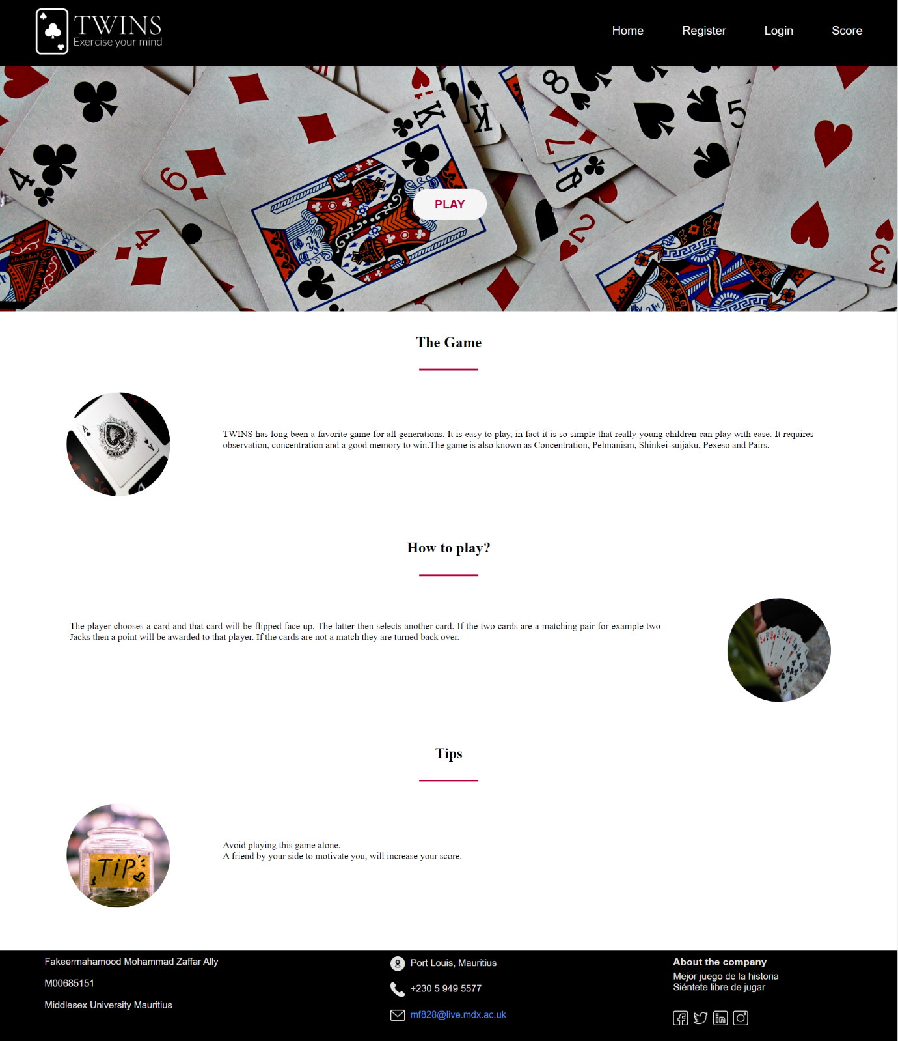

## Register

Register allows a new player to join as only registered players are welcomed to access this game.

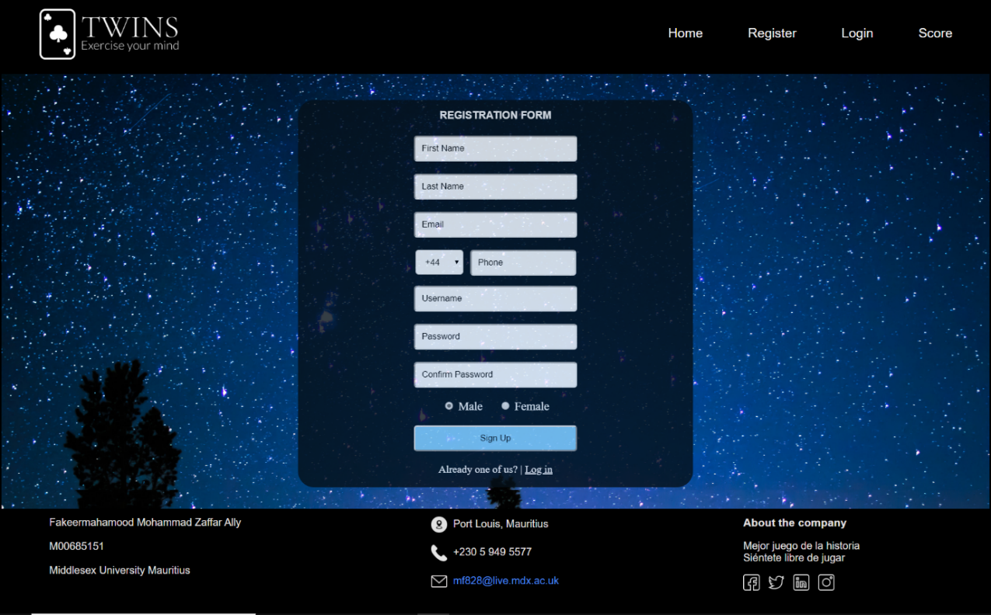

### Validation and error handling

Upon pressing the sign-up button, the website will initially check if the user missed any required input fields. In the affirmative, the latter will then be informed which fields are empty.



As a second check, the website will make sure that the user has submitted valid data for all fields such as, preventing any numerical characters in name fields, alphabetical characters in phone fields, ensuring a valid email address has been entered and so on.



A final check will then be carried out to detect if the user entered any duplicate data for username, email address and phone number (within countries).



If user data submitted meets all criteria, an account will be created automatically for the user, saved into the local storage and prompted that an account has been created.

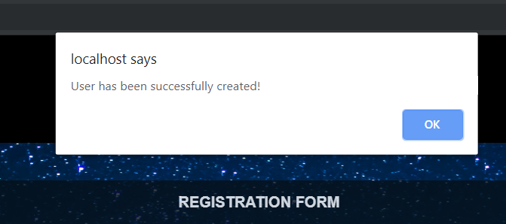

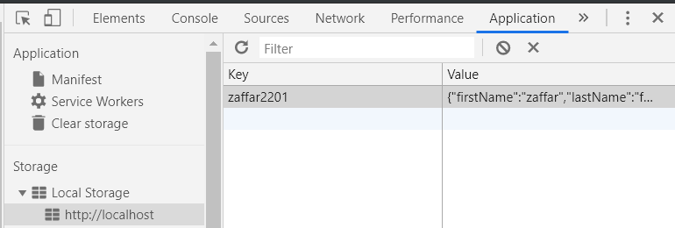

## Login

Login allows an existing player to play the game. No direct link is available to the game page, the player will have to login in order to enjoy the game.

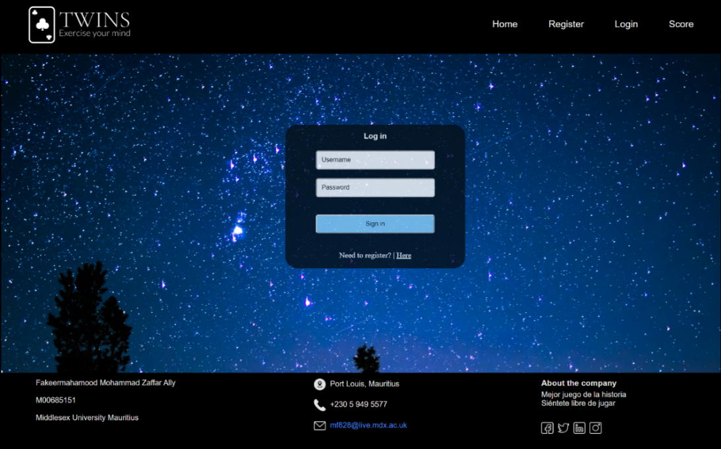

### Validation and error handling

In order to access the game, the user will be authenticated for a username and password. The website will then perform tests to determine whether access should be granted or not by:

1. Checking if account exists

The website will loop through local storage to check if username entered exists in the database. If not, inform user that account does not exists.

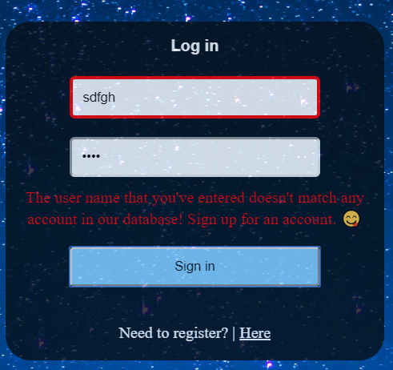

1. Checking if username and password matches

If username does exist in the local storage, the authentication process checks if the corresponding password has been entered. If not, the user will be informed else a session will be created.

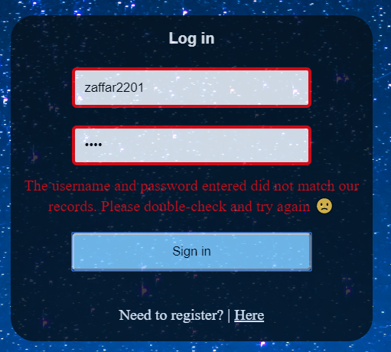

## Scores

Scores displays the highest scores of the game.

### Description

Upon loading this page, the website calls for a JavaScript function “populateTable()” which will assist in populating data into the HTML table. This is implemented by:

1. Loading all contents from local storage into an object array.
2. Sorting the object array by highest points (bubble sort then reverse array).

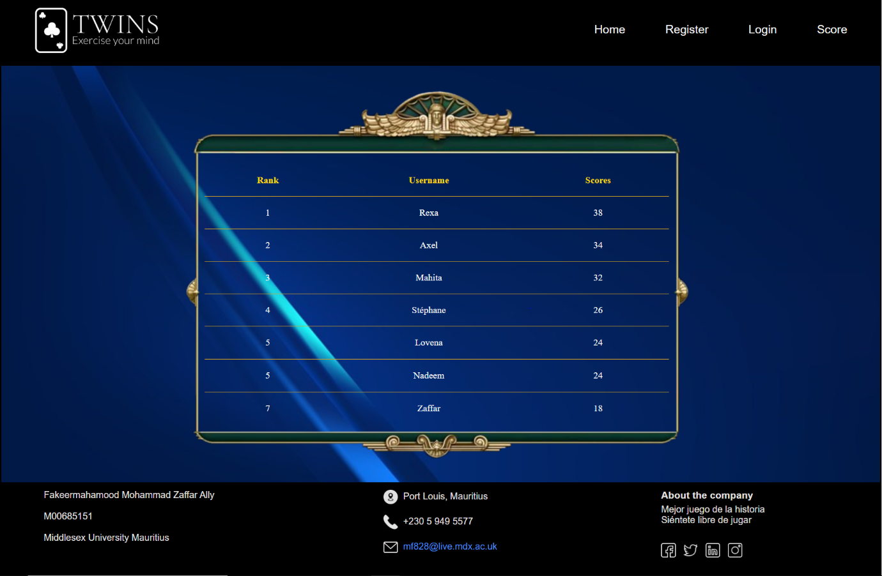

## Game page

Game animation will be displayed as shown below.

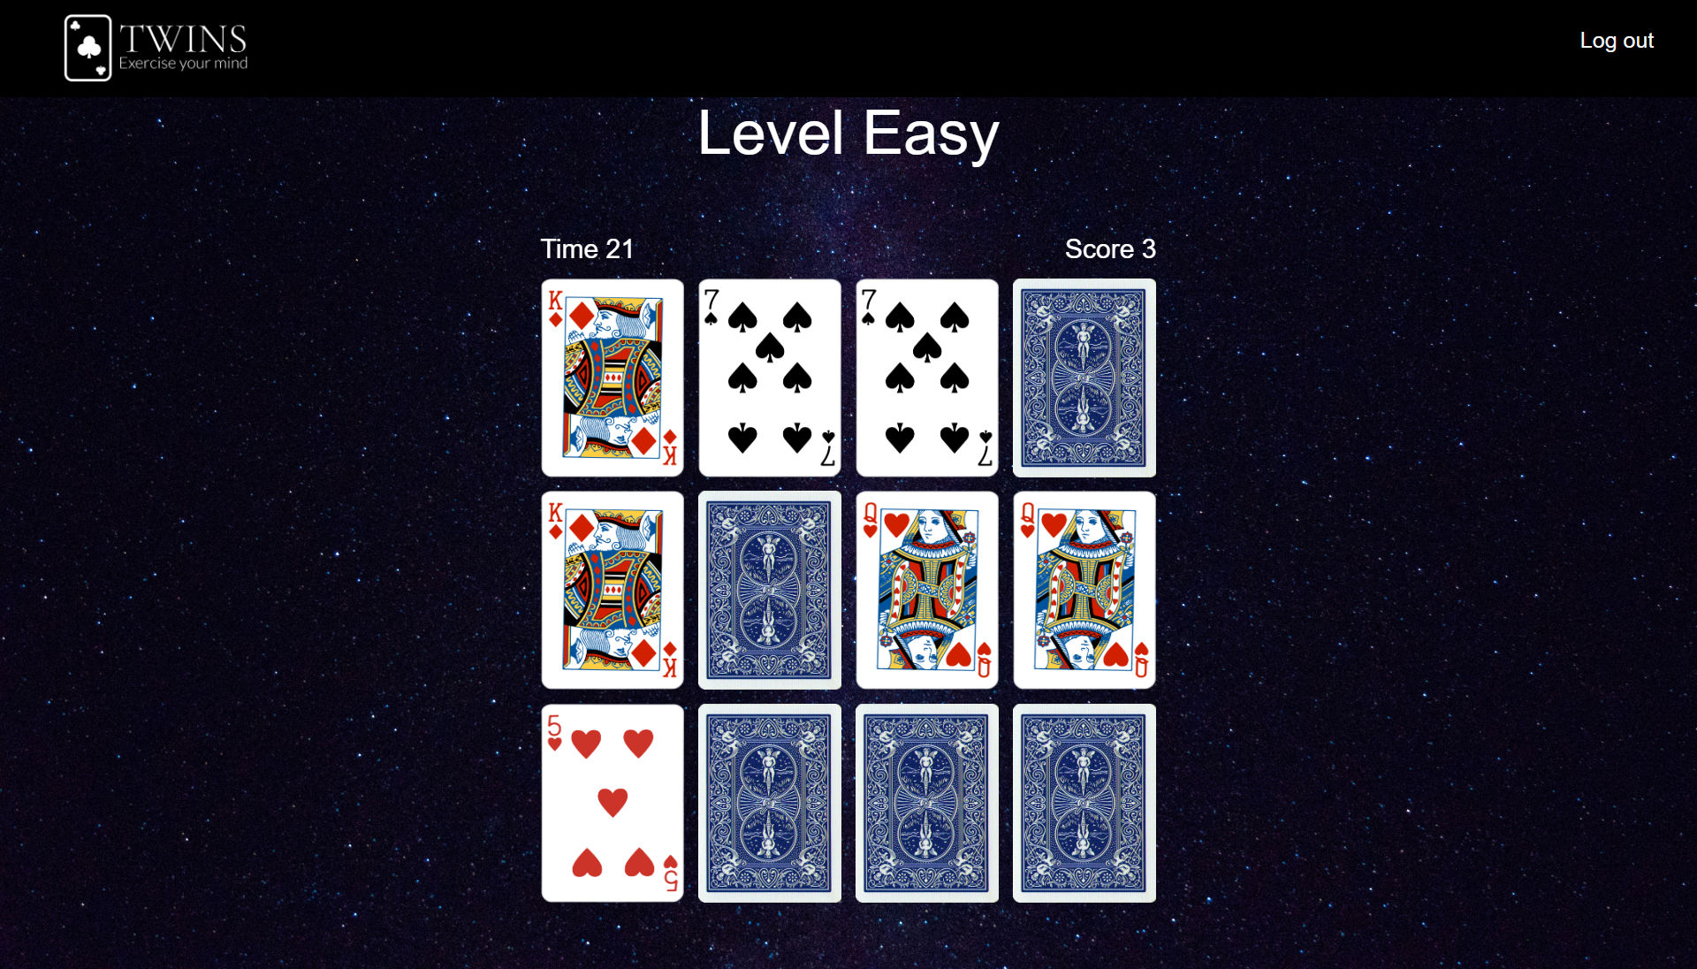

### Description

After the game has loaded successfully, the user will be prompted to choose difficulty level. Time allocated, points granted per correct match and bonus points varies with difficulty level chosen.



The game will resume one second after the user made his/her choice of difficulty. The latter will have to ensure that he/she was able to match all cards before the time limit to complete the match. Any time left will be halved and multiplied by bonus points ( depends on difficulty level). The user will then be shown his/her final score.

The game will also update the high score of the user if he/she has improved from previous matches.





*Table 1 shows how final scores are calculated*

